Hardware/Software Codesign Lab 3

Student Name: Lauro Cabral

Student ID: 012733966

1. Follow the Lab 3 manual finish Lab 3.
2. Copy and paste the following information to the end of this document and submit this document:
3. Block diagram for your hardware platform.

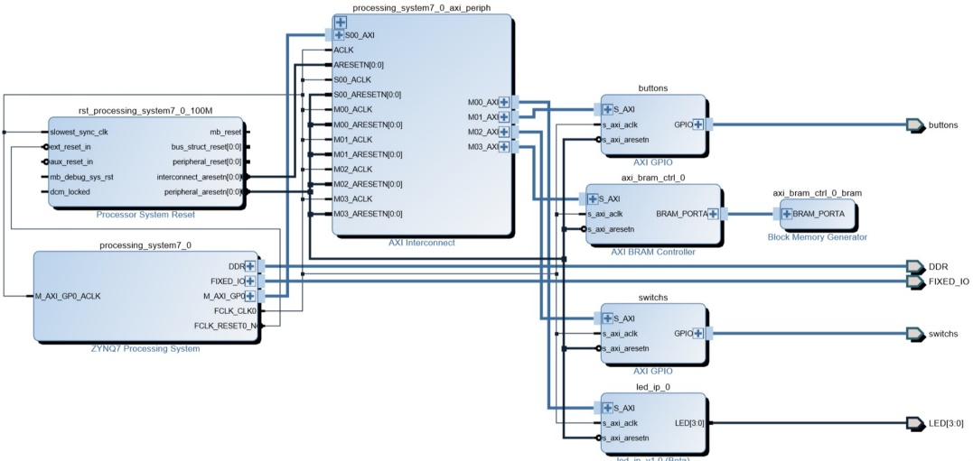

1. peripheral memory map

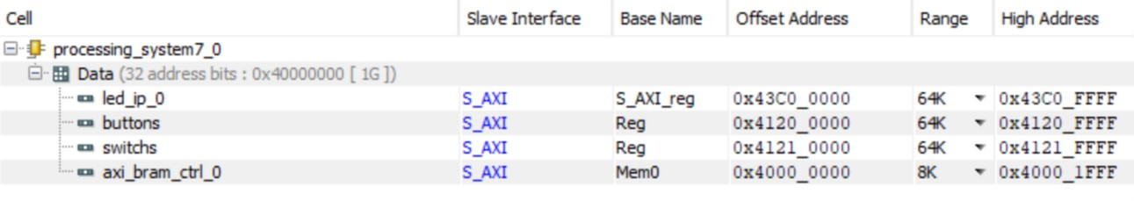

1. system.hdf: highlight information for the custom IP added and BRAM and BRAM controller.

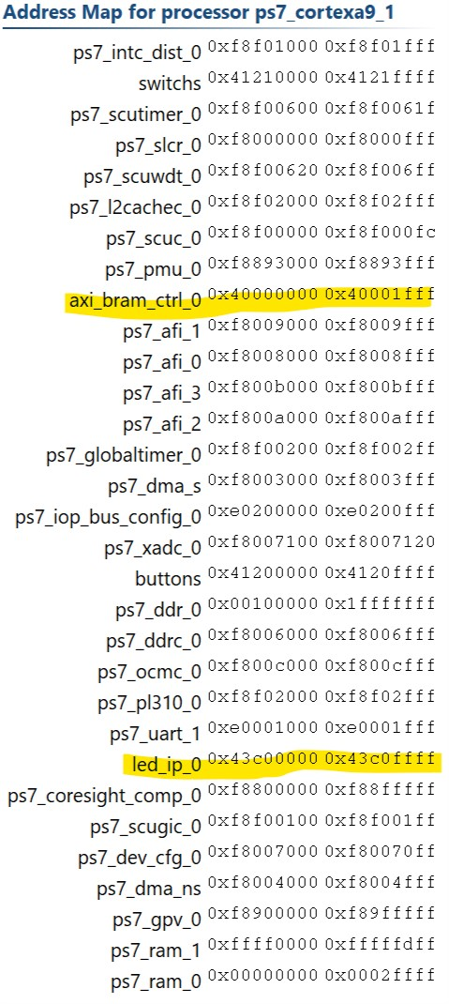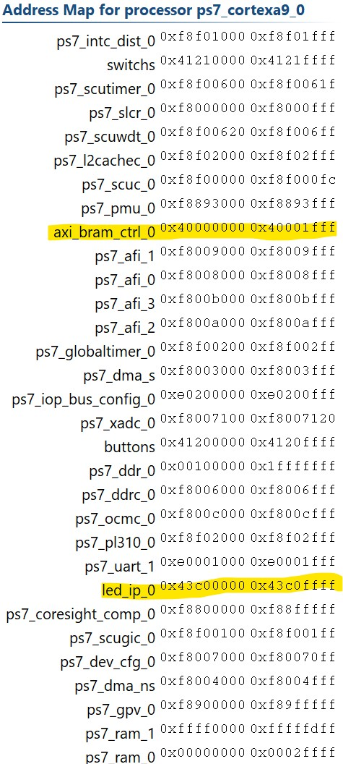

1. Pin assignment for the four LEDs

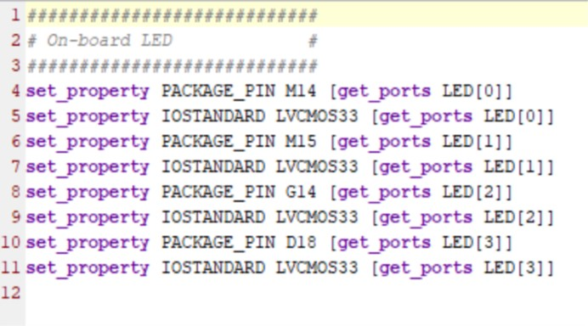

1. Answer the following question:
2. Which register in the custom IP is used to control the leds? Can we use a different one? Show the modified code to use a different register to control the leds.

The s_axi_wdata and s_axi_rdata are used for reading and writing the led values. No, we cannot use different ones as they are unique to the structure.

1. Can we move the instantiation of lab3_user_logic from led_ip_v1_0_S_AXI.v to led_ip_v1_0, why or why not?

No, as the led_ip_v1_0.v and user.v(user logic) reside inside of from led_ip_v1_0_S_AXI.v